We Play ….. We learn
"Nalaab .. Nataalam"
(Let's Play and Learn)

 |  |  | 30 | : | No. of episodes | -
 |  |  | 20 min. | : | Duration of each episode | -
 |  |  | 2 – 5 Preschool / Edutainment | : | Target age | -
 |  | Puppets & 2D animation |  | : | Type (style) | -

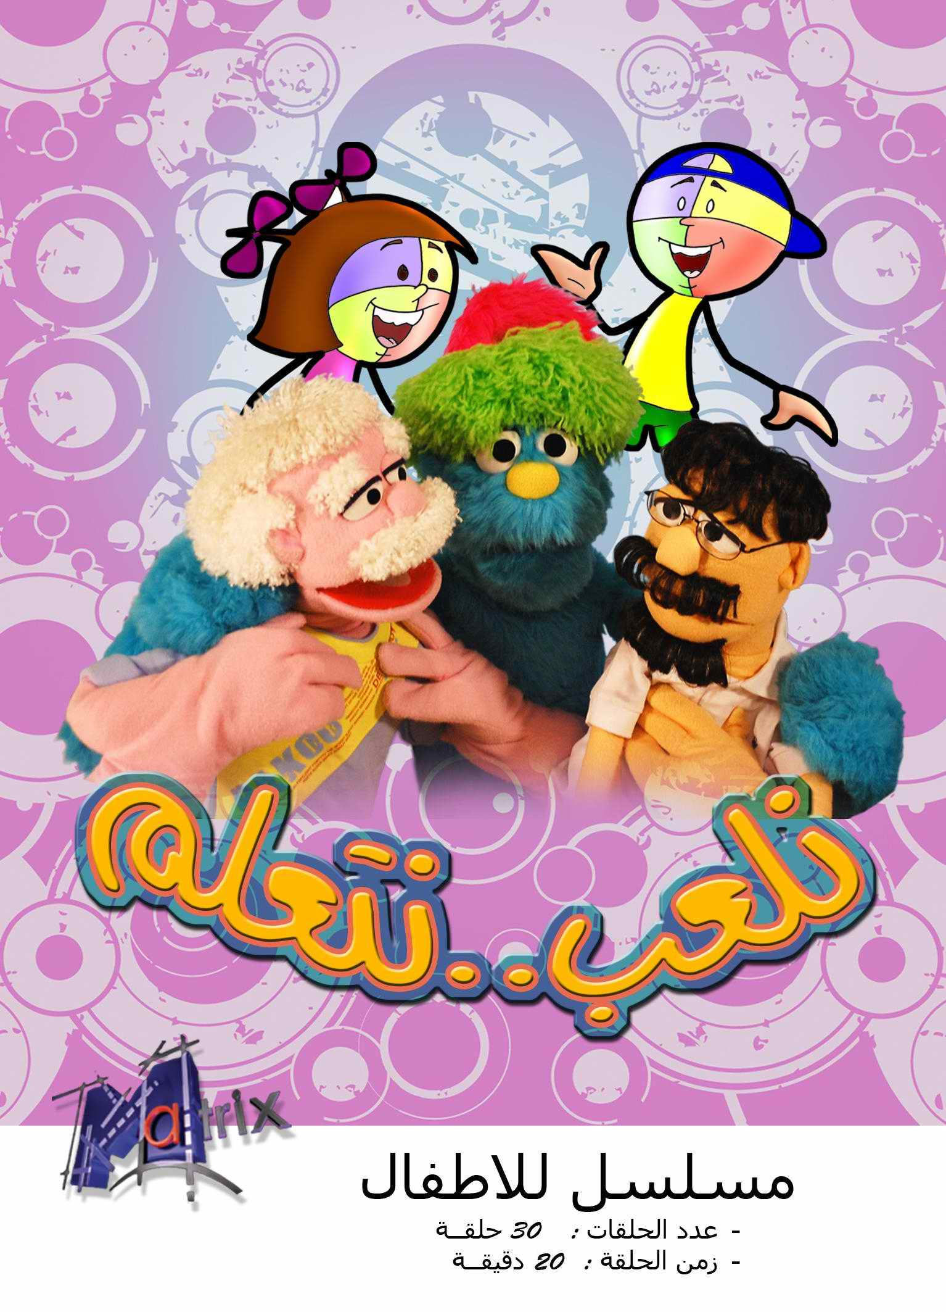
Overview:
- 1st Stage:- Tota (6 years old) and her brother Sheko's (4 years old) ; from their everyday life, we learn a lot of new info and ideas. We learn the Arabic alphabet letters, how they look like, how to write them in an easy and simple way, what words start by these letters etc… through indirect stories and events.
- 2nd Stage:- We meet (Allam) the scientist , who provides the children with a lot of scientific information in an easy simple way .
- 3rd Stage:- We meet (Al-Jid Shadid) the healthy grandpa who introduces different kinds of sports explaining it's history and manner of playing.
- 4th Stage:- the children, among other friends, encounter a problem and their way out at the end is doing a good deed.
The objective is teaching the child the importance of doing right, following rules and ethics and also religion education where a narrator at the end of the episode links the idea of the story with one of Qura'n verses or the prophet Mohamed's quotes in Islam.

Main Objectives:
- Learning Arab Alphabets.
- Knowing the main rules of kinds of sports.
- Explaining some scientific information in a simple way.
- Moral and educational directing, relating to religion.

Note: For international marketing (outside the Arabic territory), the episodes can be sold and broadcasted with only the 2nd and 3rd stages (parts).

Sample Episode:
For samples screening; visit our website (egymatrix.com) or use the following links:
- We play .. We learn (Nal3ab Nat3lam) – Intro:
http://youtu.be/dme2cr-XkY4
- We play .. We learn (Nal3ab Nat3lam) – Episode:
https://youtu.be/4eM9ENMjmWQ

